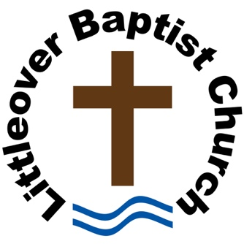
Church Sermon Recording and Publication Consent Form

Littleover Baptist Church
Thornhill Road
Littleover
Derby
DE23 6FZ
01332 770969 (office)
enquiries@littleoverbaptists.org

Consent to Record and Publish Sermon

I, the undersigned, hereby grant permission to Littleover Baptist Church to record my sermon delivered on the specified date. I understand that the recording may be published on YouTube and the Church’s website.

Speaker’s Signature: ____________________________________ Date: ________________

Church Representative’s Signature: ________________________ Date: ________________

Terms of Consent:

- Recording and Use: I consent to the recording of my sermon and understand that the recording may be used, edited, and published at the discretion of Littleover Baptist Church.
- Publication: I agree that the recording may be posted on YouTube and the Church’s web site, and that it may be used for promotional, educational, and ministry purposes.
- Rights: I waive any rights to inspect or approve the final product or to receive any compensation for the use of the recording.
- Duration: This consent is granted for an indefinite period unless revoked in writing.
- Revocation: I understand that I may withdraw this consent at any time by providing written notice to Littleover Baptist Church. However, such revocation will not affect any materials already published or distributed.

